- Developed in 1960.
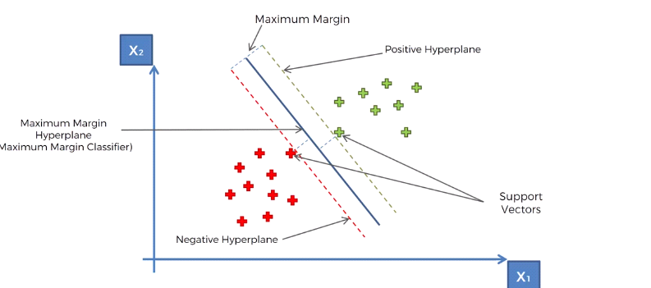
SVM is to find the best decision boundary to separate the points. Maximum margin is to have equal distance between those 2 distinct points. Those 2 distinct points are called support vectors, that helps supporting the entire algorithm. The order of positive and negative hyperplanes is not important.
**Note: support vectors are picked from the examples that are closest to the opposite group
